Why isn't that Buddha statue fat?
Saturday, 25 July 2009 • Permalink (Hivelogic)
I’m often amused when people ask me why the Buddha statues I have (or the pictures I’ve taken of them) aren’t fat.
Generally speaking, there are two types of Buddha statues, representing two completely different people. In the Western world, they are often confused, probably because the term “Buddha” can be used to refer to either of them. The difference, though, is that one of them is the Buddha, and the other is a Buddha.
Hopefully the pictures and descriptions below will help clear up any confusion.

The Buddha (Siddhartha Gautama)
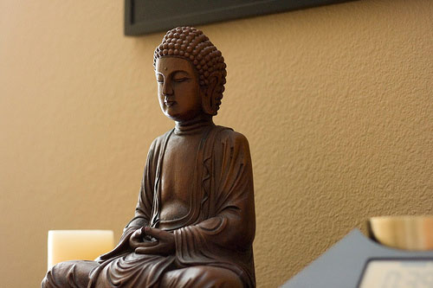
This is a statue of Siddhartha Gautama, known as The Buddha, a spiritual teacher in the northern region of India. He lived 2600 years ago, and his collective teachings became the foundation of Buddhism.
When Buddhists refer to the Buddha, this is who they are talking about. Gautama Buddha is often depicted in several different poses, including seated in meditation (with various hand positions or mudras), standing or walking, and lying down on his side, representing the different stages of his life and teachings.

.”

Hotei, The Laughing Buddha (a.k.a. Budai, Angida, Qieci, etc.)
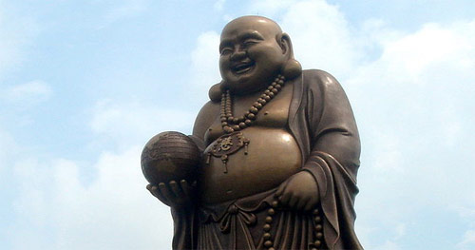
This is a statue of Hotei, the Laughing Buddha. Hotei is a character based on an eccentric monk who lived in the time of the Liang Dynasty, and who has become associate with luck and good fortune in many Asian cultures. In Buddhism, the term Buddha is sometimes used to refer to a person who has attained enlightenment through practice (Theravada Buddhists would refer to him as an Arhat rather than a Buddha). He is usually depicted as smiling or laughing, earning him the name “the Laughing Buddha.”
Now you know the difference.

