The Eightfold Path Poster
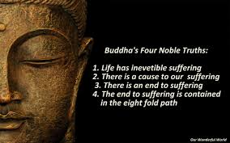
Directions:
You are responsible for creating a poster explaining Buddha’s Eightfold path. Your poster must contain all eight steps of the path as well as personal examples for the first 7 steps.
Example: Right Speech: To refrain from harmful talk and to use our words wisely. I will think before I speak and make sure no one would be offended by the things I have to say.
You will also be graded on the creativity and artistic design of your poster.

Rubric:
Creativity…………………………….2 pts
Artistic design……………………..3 pts
8fold path……………………………8 pts
7 examples………………………….7 pts

The Eightfold Path
1. Right Views: To keep ourselves free of prejudice and superstition, and to see the true nature of life.
2. Right Thoughts: To turn our minds away from the violence and hatred in this world.
3. Right Speech: To refrain from harmful talk and to use our words wisely.
4. Right Conduct: To see that our deeds come from peace and goodwill.
5. Right Livelihood: To try to earn our living in such a way that we avoid evil karma.
6. Right Energy: To use our energies to promote the overcoming ignorance and destructive desires.
7. Right Mindfulness: To cherish a good mind, for all that we think and do have their roots in the mind.
8. Right Meditation: To study the Teachings of the Buddha and to practice them to the best of our abilities.

