Description of the Qualities of Rama: Ayodhya Kāṇḍa: The Ramayana, 4th-5th c. BCE__________
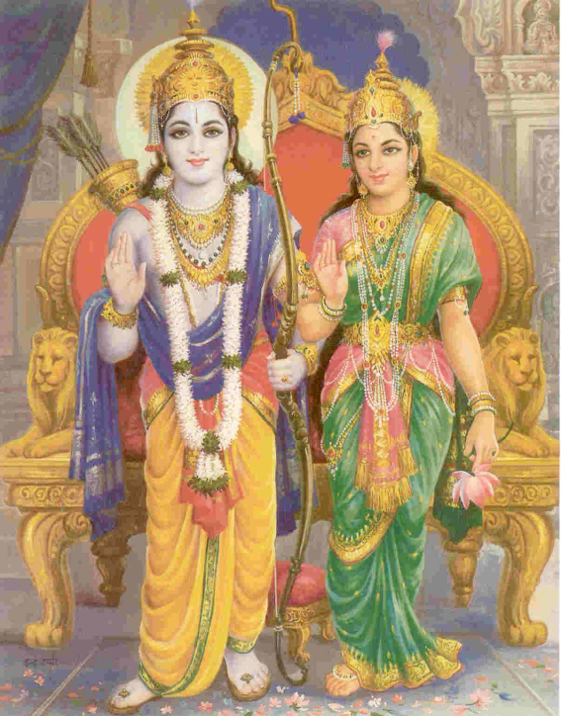
The Ramayana, originally written in Sanskrit, is one of two epics of Hinduism which was written during the 4th- 5th centuries BCE. The text describes the duties of relationships, including ideal characters like the ideal wife, ideal father, ideal king, etc. Although the text tells an epic tale it also presents the teachings of ancient Hinduism. Each character represents some element of Hindu teachings on character and the ideal behaviors for all individuals.
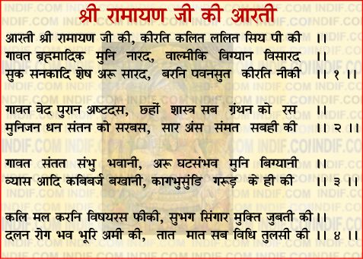
The excerpt below highlights one of the books within the Ramayana, the Ayodhya Kanda, and the description of the main protagonist Rama. Rama is described as the living embodiment of the god Vishnu the preserver. Rama lives his life and journeys through the Ramayana with perfect adherence to dharma even though he is regularly tested and challenged over time. Throughout the course of the text, Rama is continually described as unfaltering, generous, kind, and above all wise. Rama is often compared to Gilgamesh and Odysseus as they share similar roles in their respective epic texts. Today Rama is often worshipped as an avenue to Vishnu, most widely in Nepal and India.
The excerpt is based in an inner dilemma faced by Rama’s father as he is realizing he will soon need an heir to the throne and new King. The text identifies the qualities of Rama in all respects of human character. Rama’s father eventually settles on naming Rama as the heir to the throne, and the epic continues to follow the adventurous lives of the divine characters.
Source: Valmeeki Ramayana translated by Karnamrita dasa ACBSP © 1997 Volume 1 Ayodhya khanda (The Book of Ayodhya)
Description of the Qualities of Rama: Ayodhya Kāṇḍa: The Ramayana, 4th-5th BCE________________
Source: Valmeeki Ramayana translated by Karnamrita dasa ACBSP © 1997
Volume 1 Ayodhya khanda (The Book of Ayodhya)
6) Of the four, Lord Rama was the king's most beloved son, and like a Brahma He excelled all others in virtue.
9) He was endowed with supernal loveliness and heroism, and was envious of no one. He was a son unequalled in the world, and resembled Dasaratha in the possession of good qualities.
Describe the way Rama treated others:
10) He was always tranquil at heart and His speech was gentle— He never spoke haughtily to any man even though He had been reviled.
11) He was often delighted by some small service rendered Him, and being self-possessed, He would forgive hundreds of misdeeds.
13) He was intelligent, sweetly spoken, and would always speak first [thus allaying others' nervousness]. He was agreeable and valorous, but was not proud of His heroism.
14) He never spoke an untruth, He offered all respect to the learned and the elderly; the people adored Him, and He loved the people.
15) He was compassionate, mild, and the worshipper of Brahmans. He pitied the unfortunate, was conversant with the principles of religion, was always kind, and was purity personified.
16) Lord Rama always had His family's well-being in mind. He considered His regal duty to be of great importance, and He contemplated the heavenly reward of such conduct with immense satisfaction.
17) He would countenance no mischief, neither did He relish vulgar talk. Like Brihaspati, He could counter specious arguments with ease.
What do you think is important to Rama? How do you know?
18) His transcendental body was free from disease and the influence of old age. He was eloquent, beautiful, and adaptable to circumstances. He knew the heart of every man on earth [being omniscient], and He alone was aloof from the world of matter.
20) He had acquired all requisite learning, had undertaken all manner of religious vows and was fully conversant with the Vedas and the Vedic supplements. Lord Rama, the elder brother of Bharata, surpassed His father in the wielding of the bow and missiles controlled by hymns.
21) He was the benefactor of the people; He was determined and noble-minded, truthful and honest. He was tutored by elderly Brahmans who were authorities in matters of religion and economics.
22) He knew the principles of religion, regulated sense enjoyment, and the acquisition of wealth. His memory was faultless, He was shrewd, and He was conversant with both worldly conventions and Vedic ritual.
23) He was modest and reserved. He kept His counsellors' advice secret and had many companions and confidential servants. His wrath and joviality were both unfailing, and He knew when renunciation and restraint were called for.
What qualities does Rama possess that might be considered godly?
24) Rama was the personification of unflinching devotion, His wisdom was unswerving, He utterly rejected things mundane, and would never speak harshly. He was alert and infallible. He was neither unaware of the faults of His kin nor of others.
30) He was invincible in battle by either demigods or demons. He was free from spite, having subdued anger, and He was neither haughty nor envious.
38) He is desirous of the people's prosperity and He is compassionate upon all living beings. He is dearer to my subjects than I, and is just like Parjanya, the god of rain.
Questions to Consider:
1. Why is Rama referred to as “He” with a capital letter?
2. With which other mythological or religious figures would you most closely compare Rama? Why?

3. How would you compare and contrast Rama as hero with other heroes?
4. Identify three qualities of Rama and describe how they might fit into the belief that Rama was the living version of the god Vishnu who is the preserver of the universe.
Match the bold underlined terms from the text to the synonyms in the boxes below.
Term from Text | Synonym(s)
5. | Success, wealth, accomplishment
6. | Protector, backer, promoter
7. | Proudly, insolently
8. | Crude, disgusting, filthy
9. | Addition, gain, recovery
10. | Boundless, mystical, spiritual
11. | Peaceful, calm
12. | Essential, necessary
13. | Articulate, expressive, moving
14. | Practiced, proficient, skilled
Questions 10-14:
Conversant
Transcendental
Eloquent
Tranquil
Requisite

Questions 5-9:
Vulgar
Benefactor
Haughtily
Prosperity
Acquisition

