`

6th Grade history
Mummy project

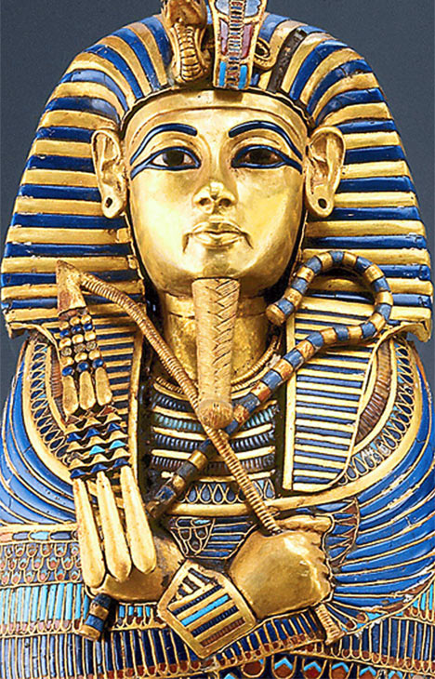

Background: In this project, you will learn about mummies and the mummification process as it relates to Egyptian history. This packet will have everything you need to complete the assignment. You will be required to turn this in at the end of the project. Everything in this packet should be filled out.

Group Members: Please list your group members below.

(Scribe)______________________________________________

(Embalmer)___________________________________________

(Orator)______________________________________________

Research: Spend time with your group researching mummies and the mummification process. Take notes on how mummies were made, why certain people were mummified and materials used to make mummies. Complete sentences are not required.

(how)___________________________________________________________________

________________________________________________________________________

________________________________________________________________________

________________________________________________________________________

(why)___________________________________________________________________

________________________________________________________________________

________________________________________________________________________

________________________________________________________________________

(materials)_______________________________________________________________

________________________________________________________________________

Sources: Which book or websites did you use in your research? Write the titles down below.

(1)_____________________________________________________________________

(2)_____________________________________________________________________

(3)_____________________________________________________________________

(4)_____________________________________________________________________

Based on your knowledge of mummies and the mummification process your assignment is to mummify an orange slice.

Materials you will need for your mummy project: An orange slice as well as anything you need for wrapping, preserving, and storing your mummy slice.

_______________________ __________________________
_______________________ __________________________
_______________________ __________________________
_______________________ __________________________

With your group, use the scientific method to conduct your mummy experiment.

1. Problem: How to mummify an orange slice?

2. Hypothesis (educated guess): Will your experiment work? Why or why not?
________________________________________________________________________

________________________________________________________________________

________________________________________________________________________

________________________________________________________________________

________________________________________________________________________

________________________________________________________________________

3. Run the experiment

4. Collect data: With your group, create an observation chart that you will use to note the progress of your mummy. Discuss with your group what needs to be in your chart. Staple your completed chart to this packet when you turn it in.
Day | Observation

5. Conclusion and speech: What was the result of your experiment? What worked? What did not? Was your orange slice mummified? Why or why not? What would you change about your experiment if you did it again?

(result)__________________________________________________________________

________________________________________________________________________

________________________________________________________________________

________________________________________________________________________

(mummified?)____________________________________________________________

________________________________________________________________________

________________________________________________________________________

(why?)__________________________________________________________________

________________________________________________________________________

________________________________________________________________________

________________________________________________________________________

________________________________________________________________________

________________________________________________________________________

(change?)________________________________________________________________

________________________________________________________________________

