Landscape Group Project
(3-4 People)

Option 1
- Design your own treasure map
  - On construction paper draw a treasure map that contains 5 of our geography terms with directions on how to find the treasure.
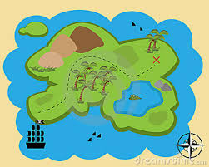

    - Materials-Construction paper or poster board, colored pencils, markers and artistic ability.

Option 2
- Design your own Island/country
  - On a poster create and draw your own country/island that contains 7 of our geography terms
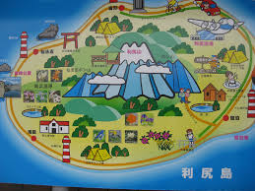
    - Materials-poster board, colored pencils, markers, and creativity.
- Option 3

- Edible landscape
  - Group will design and bake one geographical feature.
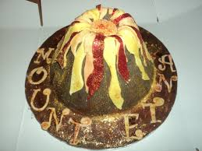
    - Parent permission/supervision to bake a cake, brownie, or cookie at home in a lined cookie sheet. Icing and other items can be brought to school to decorate. (Yes you can eat it after class!)

