Geography
Definition: The study of the world; its people and the landscapes they create.

Landscapes: A place’s landscape is all the human and physical features that make it unique.
Examples to define:
- Gulf
- Bay
- Canyon
- Valley
- Delta
- Glacier
- Isthmus
- Peninsula
- Plain
- Coast
- Ocean
- Straight
- Oasis
- Desert
- Volcano
- Hill
- Mountain
- Plateau
- River
- Lake

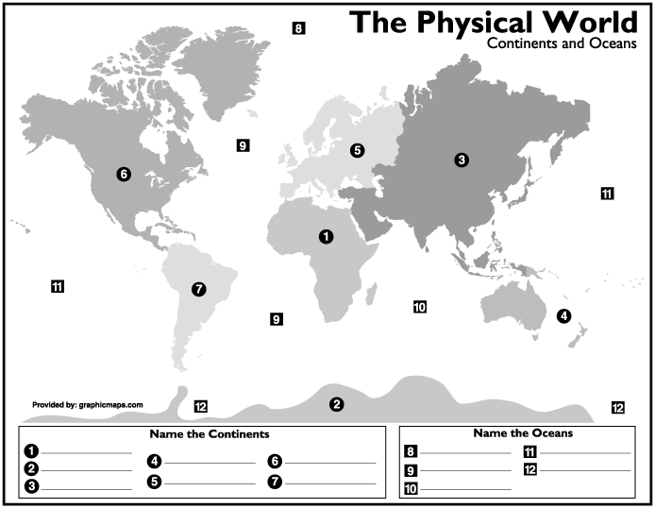

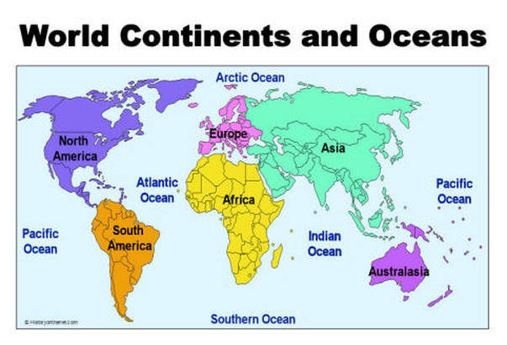

The 5 themes of Geography

I. Location (Where people and things are-2 examples)

A. Absolute
1. Longitude and latitude
2. Address
B. Relative
1. North of…..
2. 1 block from….
3. Near the …..
II. Place (described by physical and cultural characteristics)
A. Physical (natural features of a place)
1. Desert
2. Redwoods
3. Sierra Nevada Mountains
4. The Beach
B. Cultural (tourism-vacations)
1. Disneyland
2. Hollywood
3. The beach

III. Human/Environment interaction (3 different examples)

A. Humans relying on the environment
1. Fields to grow
2. Water to drink
B. Humans modifying environment for needs
1. Dams
2. Tunnel
C. Nature effecting human life
1. Tornadoes
2. hurricanes
3. forest fires
4. earthquakes
5. snow storms
6. Floods
IV. Movement (from one area to another)
A. jobs, travel, living in a better environment
B. goods
1. where are things made
2. how does that effect jobs here
C. Forced movement
1. Slavery
2. War/political persecution
D. ideas (big part of history)
1. word of mouth
2. writing (letters and books)
3. telephone
4. computer

V. Region (large area that shares unique features)
A. Cornbelt (area suitable for growing corn)
B. Bible belt (shared culture)
C. Political regions (election)

